1. **Screenshots**
   1. **Screen 1 : Intake/On-Call Employee Quick Search**

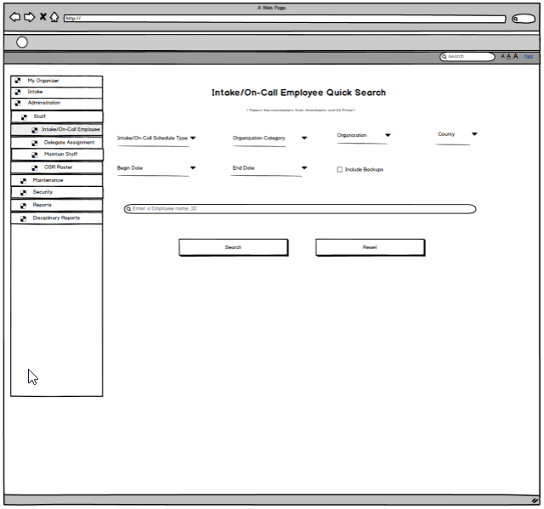

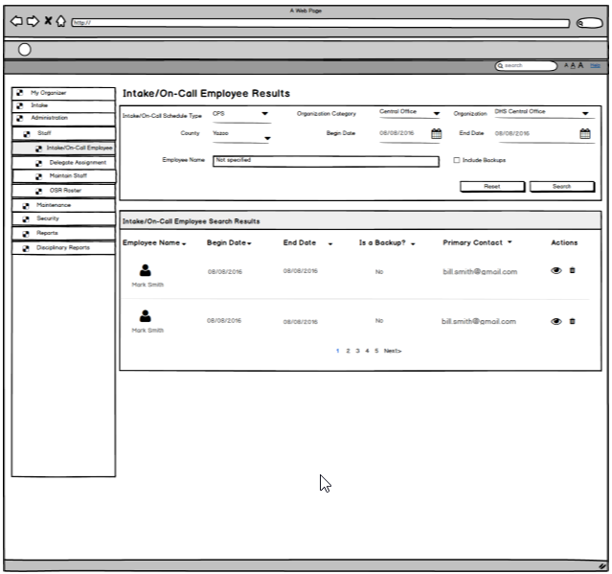

* + 1. **Screen Fields**

| **Class.Attribute Name** | **Display Name** | **Type** | **Align** | **Size** | **Read Only** | **Calculation** | **Edit Mask** | **UI Validation** |
| --- | --- | --- | --- | --- | --- | --- | --- | --- |
| N/A | Intake/On-Call Employee Search Criteria | Section Header | L | N/A | T | N/A | N/A | N/A |
| OnCallStaff.scheduleType | Intake/On-Call Schedule Type | Drop Down List | L | 100 | F | Domain Code: OnCallType | N/A | Required |
| Agency.agencyCategoryCode | Organization Category | Drop Down List | L | 100 | F | Domain Code: AgencyCategory |  | Required  Defaults to logged in user’s Organization Category. |
| Agency.agencyId | Organization | Drop Down List | L | 100 | F |  |  | Required  List of Organizations based on selection in Organization Category  Defaults to logged in user’s Organization. |
| AgencyCounty.countyCode | County | Drop Down List | L | 100 | F | Domain Code: County |  | Required  List of County(ies) based on selection in Organization |
| OnCallStaff.StartDate | Begin date | Date Field | L | 10 | F |  | MM/DD/YYYY | Required Field  Default to today’s date |
| OnCallStaff.EndDate | End Date | Date Field | L | 10 | F |  | MM/DD/YYYY | Required Field  Default to today’s date |
| OnCallStaff.IsBackupFlag | Include Backups | Check box | L | N/A | F |  |  | Indicates if Backup Intake/On-call employees should be included in the search. |
| N/A | Intake/On-Call Employee Search Results | Section Header | L | N/A | T |  |  | System generated |
| Employee.EmployeeId | Employee ID | Display text | L | 30 | T |  |  | System populated |
| Person.firstName + Person.lastName | Employee Name | Display Text | L | 100 | T |  | First Name, Last Name | System populated |
| OnCallStaff.StartDate | Begin Date | Display Text | L | 30 | T |  | MM/DD/YYYY | System populated |
| OnCallStaff.EndDate | End Date | Display Text | L | 30 | T |  | MM/DD/YYYY | System populated |
| OnCallStaff.IsBackupFlag | Is a Back Up? | Display Text | C | 22 | T | Displays ‘Yes’ if flag is true otherwise ‘No’ |  | System populated |
| PartyContactMedium.PartyContact | Primary Contact | Display Text | L | 130 | T |  |  | Derived from the contact record for the selected employee where the Primary flag is set to true. |
| N/A | Actions | Column header | L | N/A | F |  |  | This column has ‘Delete’ button |

* + 1. **Action Buttons/Hyperlinks**

| **Label** | **Type** | **On Click Action/Navigation** |
| --- | --- | --- |
| Search | Button | Returns rows that match the filter criteria |
| Reset | Button | Returns search criteria back to default values. |
| Delete | Button | Deletes Intake/On-call Employee record from the database. |
| Add Intake/ On-Call Employee | Button | Launches CF16 Find an Employee with the following data passed to CF16: Organization Category, and Organization. |

* 1. **Screen 2: Intake/On-Call Employee Details**

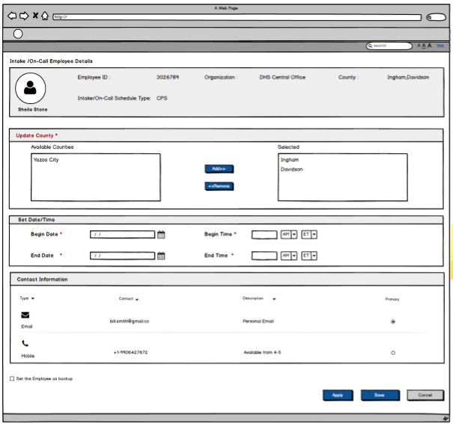

* + 1. **Screen Fields**

| **Class.Attribute Name** | **Display Name** | **Type** | **Align** | **Size** | **Read Only** | **Calculation** | **Edit Mask** | **UI Validation** |
| --- | --- | --- | --- | --- | --- | --- | --- | --- |
| N/A | Intake/On-Call Employee Details | Employee Header | L | N/A | T | N/A | N/A | System generated |
| Person.firstName +Person.lastName | Employee | Display text | L | 100 | T | N/A | N/A | Should be displayed with First and Last name under the employee picture |
| Employee.EmployeeId | Employee ID | Display text | L | 22 | T | N/A | N/A | Displays the unique identifier for an employee |
| Agency.agencyName | Organization | Display Text | L | 100 | T | N/A | N/A | System populated |
| AgencyCounty.countyCode | County | Display text | L | 30 | T | Domain Code=’County ‘ | N/A | System populated |
| OnCallStaff.scheduleType | Intake/On-Call Schedule Type | Display Text | L | N/A | T | N/A | N/A | Carried forward from the selection made on the On-Call Employee Screen. |
| N/A | Update County | Group label | L | N/A | T | N/A | N/A | System generated |
| OnCallStaffCounty.GroupCode | County | Mover Box | L | 30 | T | Domain Code=’County ‘ | N/A | Required field  List Derived from County Domain Code associated with selected Organization. |
| N/A | Set Date/Time | Group label | L | N/A | T | N/A | N/A | System generated |
| OnCallStaff.startDate | Begin Date | Date Field | L | 10 | F | N/A | MM/DD/YYYY | Required field  User entered |
| OnCallStaff.startDate | Begin Time | Date Field | L | N/A | F | N/A | Hh:mm | Required field  User entered |
| OnCallStaff.startDate | (Time Period) | Drop Down Field | L | N/A | F | Domain Code='TimePeriod' | AM/PM | Required field  User entered |
| OnCallStaff.startDate | (Time Zone) | Drop Down Field | L | N/A | F | Domain Code = ’TimeZone' | ET/CT | Required field  User entered |
| OnCallStaff.endDate | End Date | Date Field | L | 10 | F |  | MM/DD/YYYY | Required field  User entered |
| OnCallStaff.endDate | End Time | Date Field | L | 10 | F |  | Hh:mm | Required field  User entered |
| OnCallStaff.endDate | (Time Period) | Drop Down Field | L | N/A | F | Domain Code='TimePeriod' | AM/PM | Required field  User entered |
| OnCallStaff.endDate | (Time Zone) | Drop Down Field | L | N/A | F | Domain Code = ’TimeZone' | ET/CT | Required field  User entered |
| N/A | Contact Information | Group label | L | N/A | N/A | N/A | N/A | System generated |
| PartyContactMedium.contacttype | Type | Display Text | L | 30 | T | N/A | Domaint code = contact type | System populated |
| PartyContactMedium.partyContact | Contact | Display Text | L | 100 | T | N/A | N/A | System Populated |
| PartyContactMedium.partyContactdescription | Descripton | Display Text | L | 200 | T | N/A | N/A | System populated |
| PartyContactMedium.partyContact | Primary Contact | Display text | L | 130 | T | N/A | N/A | Derived from the contact record for the selected employee where the Primary flag is set to true. |
| OnCallStaff.isBackupFlag | Back Up | Check Box | L | N/A | F | N/A | N/A | Indicates if the employee will be a backup intake/on-call employee. |

* + 1. **Action Buttons/Hyperlinks**

| **Label** | **Type** | **On Click Action/Navigation** |
| --- | --- | --- |
| Apply | Button | Saves addition/modification on On-call detail page, user remains on the same page |
| Save | Button | Saves addition/modification on On-call detail page. Returns to on-call employee page |
| Cancel | Button | Return to on-call employee page |

1. **Story**

As a Supervisor, I want to create a worker on-call schedule so that I can quickly identify which workers are available to perform after-hours investigations.

**3. Notes**

**3.1 Points to Note**

* Note the following changes in Screen 1:

1. Delete the search text box
2. In the search results grid, add new column ‘Employee ID’ before the column ‘Employee Name’. The employee id’s displayed should be hyperlinks.
3. From the ‘Actions’ column, delete the select icon
4. Under the search results grid, Add ‘Add Intake/ Add On-Call Employee’ button to the left of the screen.

* Note the following changes in Screen 2:

5. Under contact information section, the radio button under the ‘Primary’ column shall be read-only

**3.2 Demo Steps**

**Scenario 1:**

1. From left hand menu navigate to Administration – Staff – Intake/On-Call employee
2. Enter the mandatory search criteria and click on search button. The list of employees is displayed.
3. Select a record from the list. The user is navigated to screen 2.
4. Update the mandatory information and click on save. The record saves and the user is navigated to screen 1.

**Scenario 2:**

1. From left hand menu navigate to Administration – Staff – Intake/On-Call employee
2. Enter the mandatory search criteria and click on search button. The list of employees is displayed or there may be no records retrieved.
3. Click on ‘Add Intake/Add On-Call Employee’ button. CF16 – user story 5, Employee search screen is launched.
4. Enter the search criteria and click on search button. Employee search results display
5. Select an employee from the list. The user is navigated to screen 2.
6. Enter the mandatory information and click on save. The record saves and the user is navigated to screen 1.

**4. Acceptance criteria**

**4.1 Screen 1 Acceptance criteria**

| **No** | **Acceptance criteria** | **Execution Event** |
| --- | --- | --- |
| 1 | The End Date can never be before the Begin Date.  User receives the following message  ‘Begin Date’ should be less than ‘End date’. | Search Button |
| 2 | The list of Intake/On-Call Employees should be sorted in order of Begin Date/Time in ascending order. If two On-call employees have the same Begin Date/Time next sort by ‘Back Up’ with ‘No’ above any ‘Yes’ values and then finally by alphabetical order. | Search Button |

**4.2 Screen 2 Acceptance criteria**

| **No.** | **Acceptance Criteria** | **Execution Event** |
| --- | --- | --- |
| 1 | The End Date/Time can never be before the Begin Date/Time. | Save Button |

**Seed Data**

Please reuse baseline seed data for this use story. Reference CF02-Screen Specifications for seed data used in this business process.